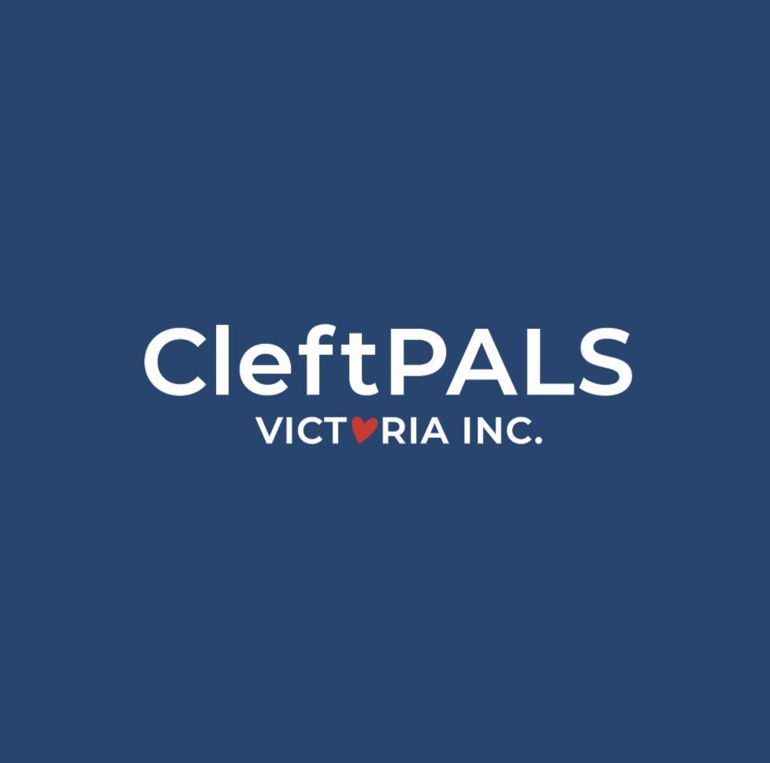

CleftPALS VICTORIA Inc.
AGM & Family Fun Day

Sunday 21 May 2023
Bounce Blackburn
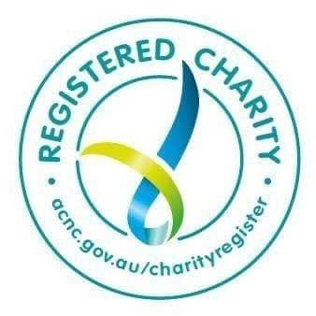

AGENDA

2:00 pm Welcome

Introduce Committee Members
Rina Bowden Vice President
Tracey Ruse Treasurer
Melissa Creber Secretary
Kirsty Pekusic Feed & Equipment
Bridie Roberts Social Media
Mark Banks General Member
Megan McIntyre General Member
Jessica Beckman General Member
Phillippa Morris General Member
Maddy Leijen General Member
Leah McMahon General Member
Mikayla Peck General Member
Beth Schultz (SA). General Member

2:10 pm CleftPALS Victoria Inc. AGM 2023

1. Opening of meeting
2. Apologies
3. Presentation of Annual Reports by Cheng Yeo
4. Presentation of Treasurer's Report by Tracey Ruse
6. Elections
7. Vote of thanks to outgoing committee members.
8. Urgent general business
9. Closure

CleftPALS VIctoria Inc. acknowledges Abroginal people as the traditional custodians of the land on which you are participating from today.
We pay our respects to Elders past, present and emerging.
We commit to working respectfully to honor their ongoing culture and spiritual connections to this culture.
We recognise the role and value of culture in our community.

PRESIDENTS REPORT 2022-2023

It is a privilege to be presenting this report on CleftPALS VIctoria’s progress from June 2022 to May 2023. This past year was again a year of rebuild and recovery for many in the community, ourselves included. Our organization is working hard to remain connected to our cleft community.

CleftPALS Victoria is fortunate to have a group of individuals in the committee, who each bring their skills, strengths and passion to ensure that we support the cleft community. I am grateful for their dedication, commitment and the many hours they put in behind the scenes to ensure that we are able to run events to support our community. The initiatives we have been able to progress are testament to the committee’s ability to work together and collaborate with other organisations.

Despite the many financial difficulties that many individuals faced due to the economic constraints of the Covid 19 pandemic, in 2022/23 many of you, your friends, your family, your work colleagues and the wider community in general ‘dug deep’ to donate to CleftPALS Victoria. This includes some very special effort of some of our youngest cleft community members doing donation drives at their local primary schools – a big shoutout to Oliver Johnston for your fundraising and awareness efforts, we appreciate it!

I am thrilled to announce that we raised a total of $10,905.57. This is thanks to your collective generosity, particularly during Cleft Awareness Week and End of Financial Year. At the end of 2022/23 financial year, CleftPALS Victoria had total funds of $69,651.22. This is $2555.75 more than the previous financial year end for 2021/22.

As for my own personal journey with CleftPALS Victoria, I discovered CleftPALS in 2010, when I first learnt that my son Josh was going to be born with a cleft lip and palate. I am eternally grateful for the connections I formed with CleftPALS during those early days, as the advice and support gave our family much peace of mind and comfort that all was going to be ok. I wish to pay forward the kindness I have received from this community, and that remains the reason why I continue to volunteer with this organization.

To the committee, I want to thank every single one of the committee for their dedication and their support for me in my first year as President. I continue to be amazed at their hard work and dedication in our collective goal to be here to support and help the cleft community.

We are passionate about educating and advancing the cleft cause. Through the advocacy and collaboration with CleftPALS NSW and Speech Pathology Australia, we continue to educate the government with the need to improve access to speech therapy for the cleft-affected community. I wish to acknowledge the incredible amount of work put in by Timothy Devlin, Jo Myers (CleftPALS NSW), Pip Morris and Jessica Beckman – who have been relentlessly following up with Senators and Members of Parliament as part of our awareness and education work. Through our discussions, we continue to work on exploring options for better funding for speech therapy.

We achieved so much this past year. I am pleased to report that we have continued to operate this organisation in a profitable manner, which in turn allows us to run the initiatives that support this community. I'm looking forward to what we can achieve in this coming year ahead.

Thank you all for attending today, I hope these events continue to help families form meaningful connections with each other.

Cheng Yeo, President.

Our achievements this year include:

- Continued improvement to our Website. This is always an ongoing project and we welcome and value your suggestions and input. https://www.cleftpalsvic.com is an informative and professional website. It should be everyone's first point of contact, as it contains a wealth of information, Hospital links, feeding and surgery advice and our online shop containing a wide variety of speciality feeding bottles and spare parts. Please jump online and have a browse.

- Study Prizes and Awards. Like our previous years, we will present four $500 study prizes in 2023. They are awarded to outstanding student midwives at Deakin, Monash, Latrobe and Australian Catholic Universities. We are pleased to be able to offer an inaugural bursary to an outstanding student from the Masters of Speech Pathology course at University of Melbourne. With COVID social restrictions behind us, the committee was able to present the awards in person again.

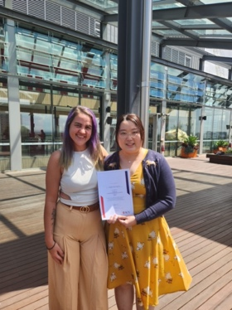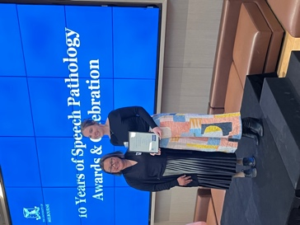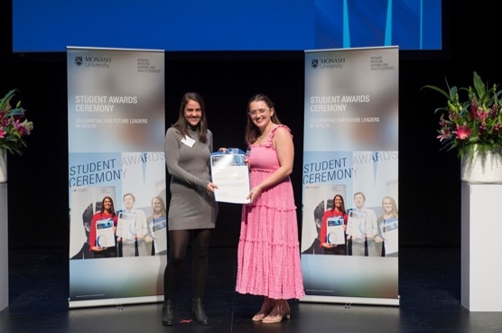

- CleftSTARS Victoria. CleftStars is a support group for children and young teens aged 8-20+ years. This past year, we have held 1-2 virtual events via Zoom to engage with this cohort to ensure that they do not feel alone with the challenges and surgeries they face. We have not had the capacity to hold in-person events as we did not have CleftSTARS mentors during 2022. If you would like to be involved with CleftSTARS or have ideas about how we can engage this cohort, we would love to have you join the committee as a General Committee Member. Please reach out to us via email Attention CleftSTARS.

- Social Media – Facebook and Instagram. The importance of social media and immediate contact with other members of our cleft family cannot be underestimated. Because of this, we are constantly posting information via social media. Our Facebook Support Group is one of our main communication platforms, as well as our Instagram page and we have recently joined Twitter. The committee moderate them most strenuously. Our public Facebook Group is currently sitting at over 1,300 members and Instagram is continually growing with 500 followers. Our Facebook group allows cleft affected families to seek support and knowledge without the need to financially belong. As such our membership has suffered. These valuable dollars are missed. Please think about becoming a financial member and help support CleftPALS Victoria Inc.

- Special Events.

Our annual family fun day and AGM for 2021 was held at Ashburton Lawn Bowls. We were pleased to welcome at least 6 new families who are at the beginning of their child’s cleft journey. It was a fun filled afternoon for the children with a few having a go at some lawn bowls fun, and a wonderful opportunity for families to meet each other and share their journeys and experiences with each other.

We also held an event during Cleft Awareness Week (Nov 8-14), where we welcome Nelson Leong and Amy McLeod from Monash Children’s Hospital who spoke about the importance of mental health support during a child’s cleft journey. We had the pleasure of hearing from Raphael Milmeister (13 years old) who spoke to the challenges he faced at school from looking different, and the strategies he put in place to overcome those challenges.

We thank Raphael for his candid and honest reflections, and we wish him all the very best for his Duke of Edinburgh Award.

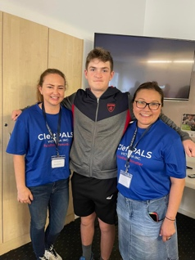

- Mr Joel Solomon OAM and Ruth Solomon. I wish to make special mention of the continuing support of our founding members Mr. Joel Solomon OAM. and his wife Ruth. I personally would like to thank Joel and Ruth for their continued support and advice. Joel continues to lobby extremely hard for CleftPALS Victoria. Thank you Joel and Ruth so very much for your continued support. We look forward to celebrating CleftPALS Victoria’s 50th Anniversary next year in 2024.

- Newborn Care Packages.

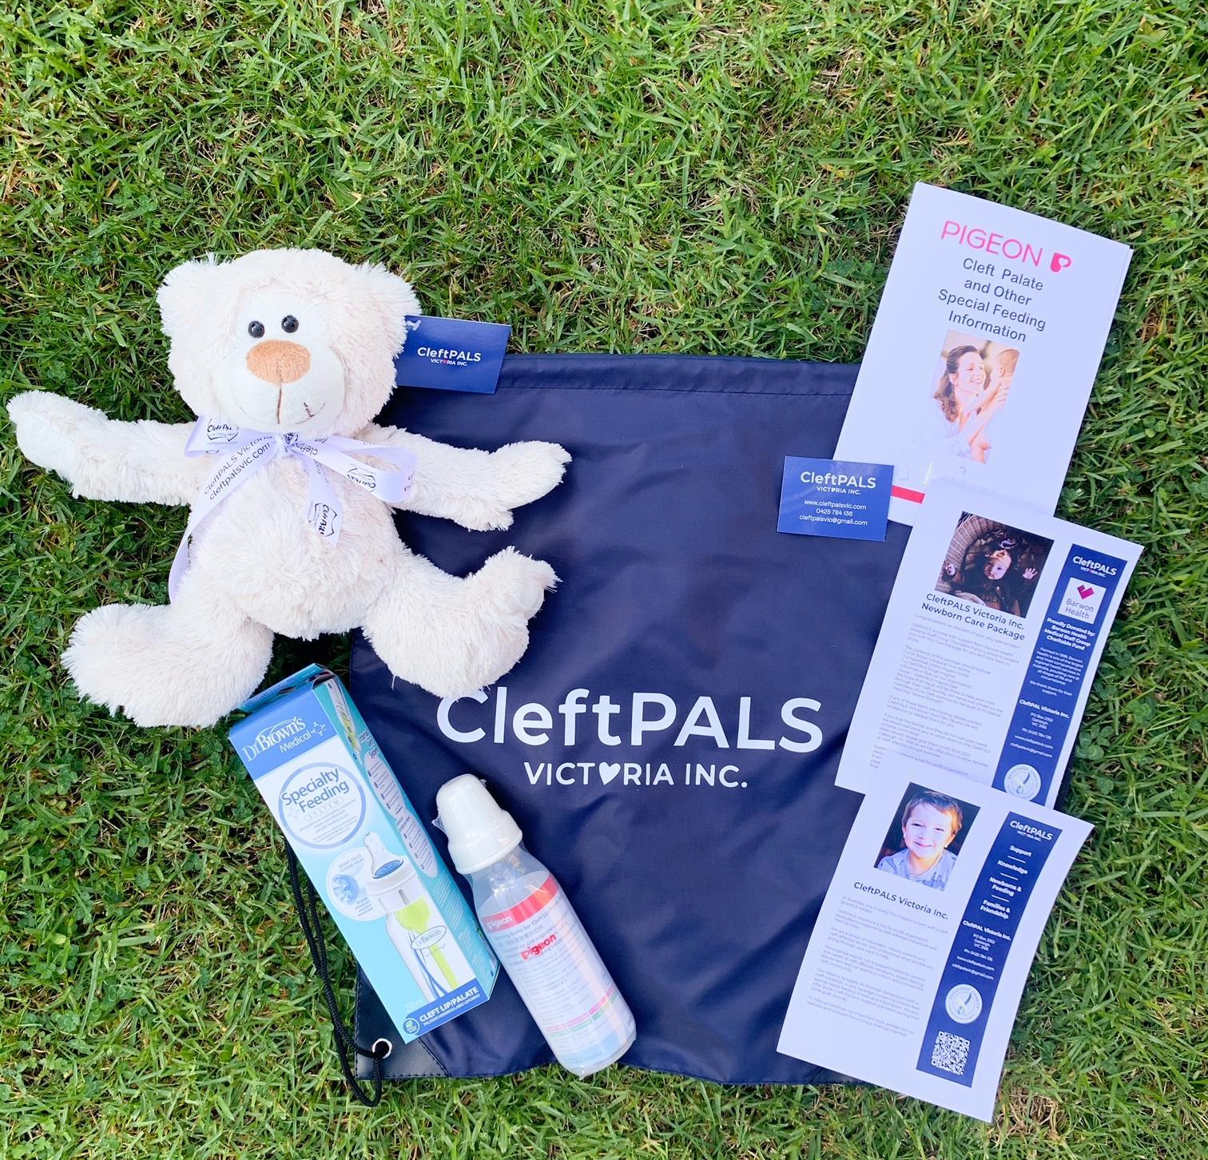
We are pleased to be able to continue with distribution of newborn care packs to cleft-affected families. These Packs are given to families of newborn cleft affected babies throughout Victoria (and other states if members are financial). We are always seeking financial donations or corporate sponsorship so that we can distribute more of these care packs. This is one project that the entire committee is very passionate about and hope to continue for many years to come.

- Bone Graft Care Packs.
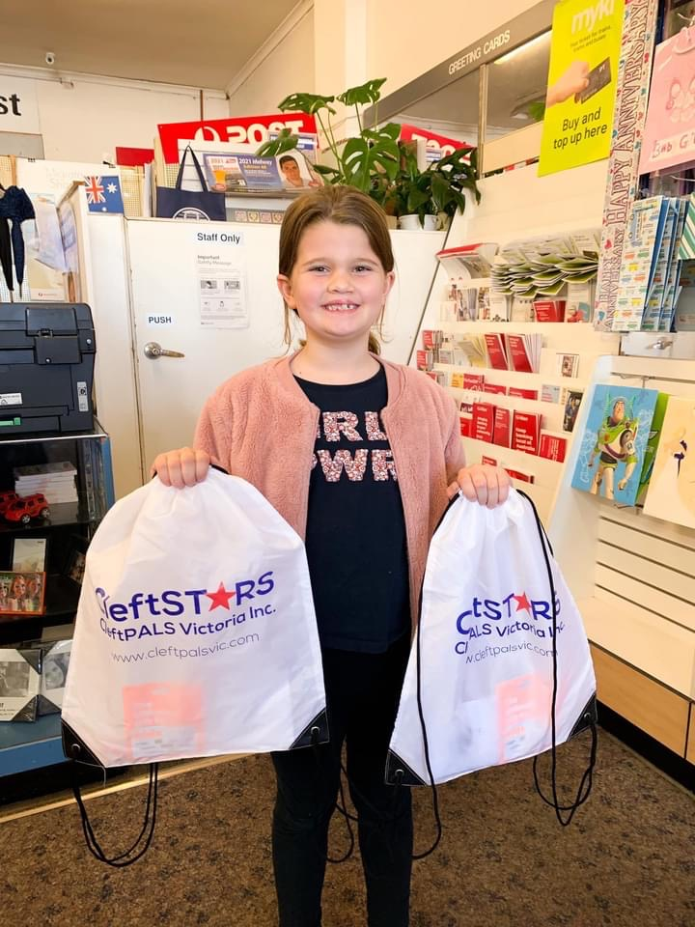
CleftPALS Victoria is pleased to continue the distribution of Bone Graft Care Packs have been available for you and your child, in preparation for their bone graft surgery. The contents of this package will contain a $30 Teen Gift card, a boredom buster toy to keep you occupied during your hospital stay. 1 x CleftPALS Fridge Magnet and Printed Information Booklets & links to some other information you might find helpful, such as recipes and recovery tips. Our packs contain practical advice from families who have undergone bone graft surgery, to help answer questions you or your child may have about preparing and recovering from this surgery.

- CleftPALS Victoria Oscar Cleft Bear
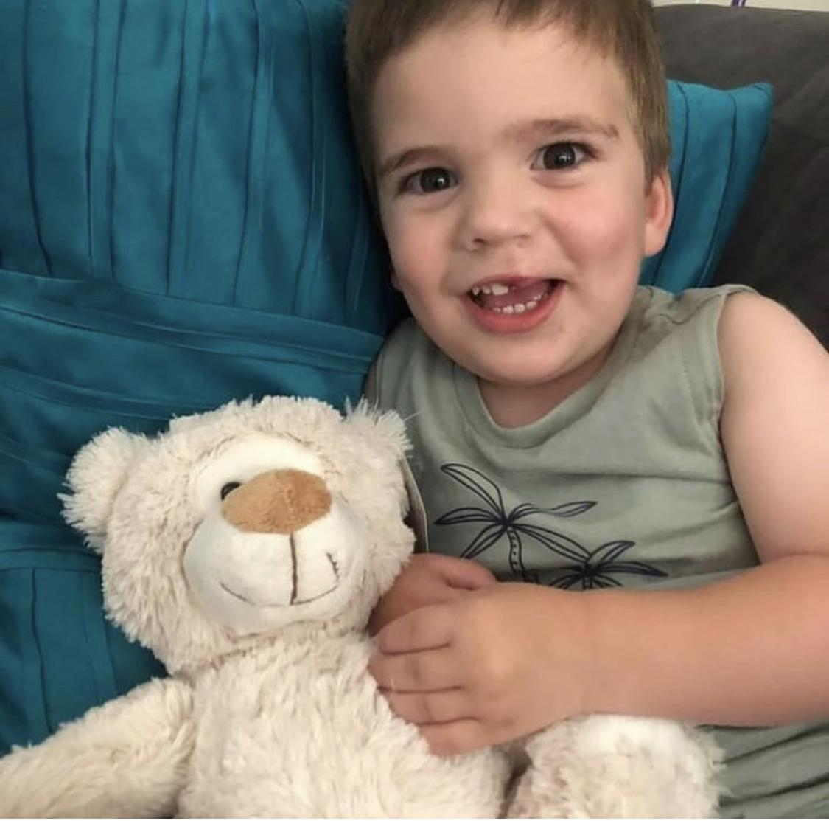
Our mascot Teddy has been redesigned and he is... oh so cuddly!! His name is OSCAR, which means “divine strength”. Oscar will be distributed to all new financial members as part of their welcome pack. He makes for really cute gifts!

10. Newsletters. I’m so thrilled to announce that our Newsletters are a huge hit! A massive Thank You to our 2022 editors, Kayla Doncon and Fiona Wallace. I wish to thank Kayla and Fiona for their dedication to make these editions happen. These informative issues are distributed quarterly to all financial members. Our issues contain articles about:

* AGM event details including guest speaker details.
* CleftSTARS events coming soon
* Meet the current President and read her report.
* Feeding and equipment - links to shop.
* Fundraising.
* Pictures of the Family fun days and social events
* Interviews with medical professionals
* Help and support advice.

Due to personal circumstances, Kayla and Fiona both had to step back from their roles during 2022. We have not been able to produce a newsletter during the second half of 2022/23 as a result.

11. Contact Parents. We are re-invigorating the Contact Parent Network. Although social media remains the primary means for families to connect with other families to ask questions, we recognise the importance of human connections in supporting each other through milestones of each child’s cleft journey. With this in mind, the committee put a callout to the Facebook group for families who are willing to be contact parents. We are pleased to report back that we have had over 12 families reach out to us willing to be contact parents.

12. Advocacy: Improved Access to Speech Therapy

We continue with our advocacy work this year after the intense campaigning during the 2022 Federal election. With the new government in place, we set about engaging and educating members of parliament about the cleft condition, and why speech therapy is a critical part of a child’s clefr treatment.

In collaboration with Speech Pathology Australia and CleftPALS NSW, we engaged with the opposition and the offices of NDIS and Health to understand what pathways exist for inclusion of speech services under Medicare or NDIS.

Our best path forward is to continue to engage to lobby for the expansion of the Medicare Cleft Lip and Palate Scheme to include speech services, on the basis of a high correlation between dentition and speech.

I want to acknowledge the hard work of the subcommittee:

• Jess Beckman, who stepped up to lead this campaign as I moved into the President role.
• Philippa Morris, who has spent much time gathering best practice research and writing to the Minister and Assistant Minister of Health.

I want to also acknowledge the collaboration between CleftPALS NSW. Jo Myers and Tim Devlin: thank you for engaging together with us with Members of Parliament and Senators.

A big thank you to all of you, for opening up to us and entrusting us to tell your stories as we continue to do this important advocacy work.

Donating to CleftPALS Victoria Inc. is one click away!

Every dollar ($2 and above is tax deductible) helps us reach our goals and supports our cleft community. As a non-for-profit Australian charity, with no government funding, we rely on donations and grants in order to continue to run our organisation and stay viable. Please visit our website www.cleftpalsvic.com or scan our QR code.

PROJECTS FOR THE FUTURE.

- Continue to produce our Newborn Care Packs, and distribute them to all new cleft affected babies born in Victoria, SA and Tasmania.  - Continue to produce Bone Graft Care Packs – to distribute these care packs to young teens and support them through their bone graft journey.  - Develop ways to encourage an increase in financial membership.  - CleftSTARS leadership to engage and increase participation.  - Continue to lobby the Federal Government to include Speech Therapy in the Medicare Cleft Lip and Palate Scheme and NDIS | 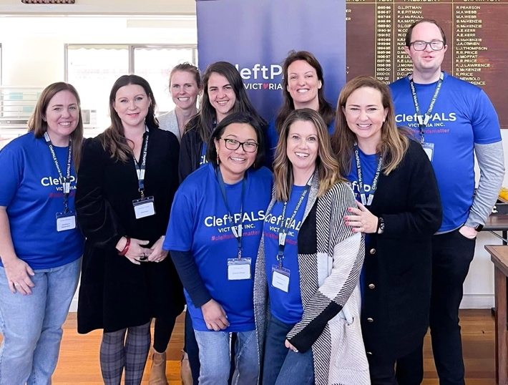

TREASURER’S REPORT 2022-2023

At the end of the 2022/2023 financial year, CleftPALS Victoria had total funds of $69,651.22. This is $2,555.45 more than the previous financial year end for 2021/2022. This is the fifth year in a row that we have made a profit.

New membership for this financial year totalled $1025, up by $290 from the previous year. Annual membership was phased out this year, leaving the $90 for lifetime family membership available. This year we received a total of 11 lifetime memberships and 1 annual memberships.

The addition of the donation option to the Facebook pages and website have continued to allow for convenient and easy payment options via PayPal. The generosity of our community saw the donation total to be $10,905.59. The promotion of Cleft Awareness Week in November and End of Year donation opportunities are again when the majority of the funds were received.
Feeding equipment income was $4,314.50, an increase of $339.05 from the year before. Feeding equipment costs were $2,167.66, an increase from the previous year of expenditure of $1020.51.

This year we were granted two separate grants that assisted in the purchase of a shared laptop and for event day expenses. We continued to support many universities in their midwifery awards, with students receiving a $500 payment to be recognised for their studies and to support their nursing careers.

New expenses this year included the reproduction of the Clancy has a cleft book ($488.55) for purchase on our webpage, as well as storage facilities ($926.50) for the many assets that have previously been stored at committee members homes.

Since 20 January 2014, CleftPALS Vic has been managing CleftPALS Tasmania’s funds, which is currently $3,708.10, with no continued sign of this becoming active again in the near future.

STATEMENT OF CASH RECEIPTS AND PAYMENTS
1 April 2022 – 31 March 2023

Income |  | $ | $
 | Clancy Books | 30.00 | 25.00
 | Donations | 10,063.10 | 10,905.59
 | Event Income | 660.00 | 250.00
 | Feeding Equipment | 3,975.45 | 4,314.50
 | Grants | 500.00 | 2000.00
 | Interest | 59.23 | 70.48
 | New Membership | 735.00 | 1,025.00
 | Oscar Bears | 160.00 | 80.00
 | Wonder Books | 75.00 | 15.00
 | Total Income | 16,374.34 | 18,685.57
Expenses
 | Awards – Midwife | 1,000.00 | 2,500.01
 | Clancy Books Production |  | 488.55
 | Event Expenses | 2,232.92 | 4,191.53
 | Feeding Equipment Purchases | 1,020.51 | 2,167.66
 | Gifts and Donations | 385.50 | 220.00
 | Insurance | 1,426.26 | 1,479.50
 | Office Expenses | 1,861.80 | 2,396.70
 | PayPal Fees | 123.54 | 87.94
 | Postage and Delivery | 1,196.80 | 1,395.08
 | Refund | 225.80 | 216.65
 | Storage |  | 926.50
 | Telephone | 70.00 | 60.00
 | Total Expenses | 9,870.51 | 16,130.12
Net Income |  | 6503.83 | 2,555.45

Opening Accounts  Balance as of 31 March 2022 |  | $
 | PayPal Account | 1,039.77
 | Westpac Cash Reserve | 10,443.28
 | Westpac Community Solutions Cheque Account | 22,313.87
 | Westpac Term Deposit | 33,298.55
 | Total | 67,095.47
Closing Accounts

Balance as at 31 March 2023
 | PayPal Account | 462.68
 | Westpac Cash Reserve | 10,513.76
 | Westpac Community Solutions Cheque Account | 25,375.93
 | Westpac Term Deposit | 33,298.55
 | Total | 69,651.22

FEEDING AND EQUIPMENT REPORT 2022-2023
The feeding and equipment hotline has continued to be an important point of contact for new parents and family members of cleft affected children.
Throughout the last year CleftPALS have continued to receive calls and emails from new and expecting parents with general questions and concerns they have after recently being given a diagnosis that their baby will be born with or has been born with a cleft. The number of calls received each week can vary between nil to an average of two to three. The number of orders received for bottles and equipment can vary week to week from nil to three or four orders in a week. Newborn care packages produced with grant money from Barwon Health continue to be provided to new babies and their families.
The CleftPALS Victoria Facebook page continues to grow with new members, and this page is a popular platform whereby many members seek feeding and equipment advice from each other and share their stories and photos.
Our website www.cleftpalsvic.com is the best place to purchase any bottles or parts needed. The Dr Brown's Speciality Feeding System for cleft babies has proven to be a popular and affordable option, and we stock these alongside the Medela Special Needs Feeder and Pigeon bottles.
We also have our mascot, Oscar Cleft Bear available for sale and some books which cleft affected children love! Please do not hesitate to reach out to the hotline if you have any questions.
Kirsty Pekusic, Feeding and Equipment

SOCIAL MEDIA REPORT 2021-2022
During 2020 it was decided to have a social media coordinator to promote CleftPALS Victoria and further support members. Instagram and Facebook are integral in promoting CleftPALS Victoria and supporting families that are cleft affected. During 2022/2023 the Facebook support group has grown to 1.4K members, an increase of 1,000 in the previous year. This group can only be accessed privately with members needing to answer membership questions to be accepted. This group allows members to connect with other members, asking questions and sharing experiences. The committee moderate this content strenuously to ensure it stays as a supportive and safe sharing space. On the support page CleftPALS Victoria is promoted and facilitates a safe sharing space.
In April 2022, a public Facebook Page was created, in-line with our public Instagram account. This page enables followers to share posts on their social media account, which is integral to sharing much needed information and donation links.
CleftPALS Victoria’s Instagram account has grown from 500 to 575 followers this past year and is able to be viewed publicly. Instagram promotes CleftPALS Victoria; personal stories are shared and general cleft information is posted.
Social media played an integral part in raising much needed awareness during our #cleftwordsmatter campaign in April 2022 and during Cleft Awareness Week which is held annually 8th-14th November.
During CAW, the online campaign via Facebook and Instagram, raised a substantial amount of money purely virtually. These donations have ensured CleftPALS Victoria can continue to run viable and continue to hold events to support our cleft community.
With the social media platforms it has become apparent that it is difficult to have financial member exclusive information, this is an ongoing issue which the committee is further investigating.
If you wish to join any of our social platforms, please see the links below.
Instagram: @cleftpalsvic
https://www.instagram.com/cleftpalsvictoria/

Facebook CleftPALS Victoria Support Group:
https://www.facebook.com/groups/26750563559/?ref=share_group_link

Facebook Page
https://www.facebook.com/cleftpalsvictoria?mibextid=LQQJ4d

Twitter: @CleftpalsV

Bridie Roberts, Social Media - Committee Member.

NEWSLETTER REPORT 2020-2021

The committee would like to acknowledge the support and hard work from our newsletter co-editors for 2022, Kayla Doncon and Fiona Wallace. Personal circumstances have meant that both editors resigned from the committee during 2022. We could not have put out the news and content out to our community without your dedication, and we are grateful for the time you gave CleftPALS Victoria.

We are recruiting for a newsletter editor. If you are interested in volunteering for this role, please reach out to any of the committee. We would love to have you onboard!

